Who are we?
Black Women in Sport Foundation provides a diverse staff of mentors and instructors with specialized training in life skills, education and athletic training. We have historically captured the interests of our participants by having a sport "hook" in all our programming.

For over 30 years BWSF has worked in the Philadelphia area providing programming to children. Our programming is offered year round to youth from pre-kindergarten through twelfth grade. Generally we provide our services in after school and summer programs, as well as collaborate with recreation centers and other non-profit organizations.
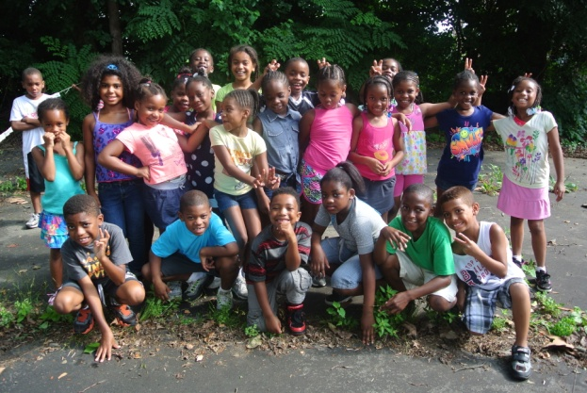

It is our goal to achieve community outreach through quality programming. Quality is a crucial element of our organization. We require staff to obtain necessary certifications and complete our specialized training. We are a professional organization and we demand the same from our employees.

Athletic Programs
Over the years, the Black Women in Sport Foundation has watched young fledgling participants emerge from our sports training initiatives transformed into strong, confident, and highly proficient leaders in their own right.

Our programs include specialized training in Fencing, Tennis, Golf, Field Hockey, Lacrosse, and Soccer. However, we are not limited to these sports.
BWSF provides the necessary equipment to run athletic programming at any athletic facility and our staff is trained to mentor and coach children ages preK-12.
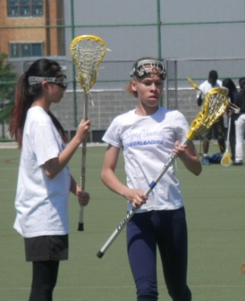
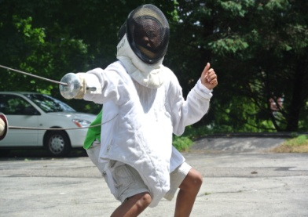

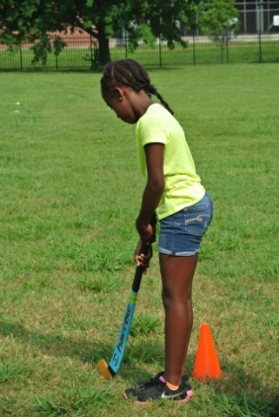
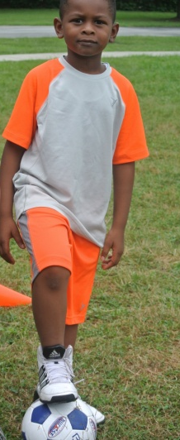
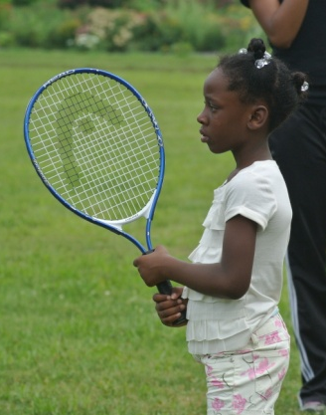

Life Skills Instruction
One of the greatest responsibilities and privileges of the Black Women in Sport Foundation is to invest in the training of future leaders. In addition to sports training, organized competition, and other athletic programming, we also offer life skills instruction to all of our participants.

BWSF has produced the three separate curriculums: After the Whistle Blows, Amazing Grace, and Exploring Sports and Science, as well as collaborative anti- violence curriculum with the Starfinder foundation called, Safety Nets.

The instruction in the aforementioned curricula includes lessons on:

- Self- Esteem
- Diversity
- Anger Management
- Conflict Resolution
- Leadership
- Goal Setting
- Peer Pressure
- Bullying
- Teamwork
- Health and Nutrition
- And several other topics
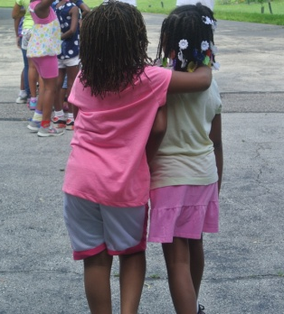

History
The Black Women in Sport Foundation was founded in 1992 by Tina Sloan Green, Alpha Alexander, Nikki Franke and Linda Green. As a non-profit organization, BWSF is dedicated to increasing the involvement of Black women and girls in all aspects of sport, including athletics, coaching and administration.

The foundation's ongoing mission is to:
- provide educational programs;
- provide appropriate life experiences through sports; and
- facilitate the development of resources for and about Black women.
In our first decade and a half we have had many major accomplishments including: developing inspirational videos and mentoring manuals, hosting golf and tennis clinics throughout the U.S., hosting our annual national conference, and creating a scholarship program.

We support extensive golf, tennis, fencing, and lacrosse programs with schools. We also offer sport mentoring programs that include sport science, writing, literacy, and life skills.

In the coming years we plan to expand our reach in a variety of ways, through the Internet, sport clinics, grant awards, consulting services for athletic program development, and finally through collaborations with educational institutions and corporate stakeholders to design, manage and promote athletics programming.

"AMAZING GRACE: Black Women in Sport" Strength, skill, speed, grace - African American women have done it all in sports, blazing new trails and setting higher standards of excellence. They are an inspiration to young women everywhere. This 25 minute video by Robin Roberts features Althea Gibson, Florence Griffith Joyner, Wilma Rudolph, Jackie Joyner Kersee, Zina Garrison, Debi Thomas, and Dominique Dawes... Companion Life Skills Manual also available! Order the "AMAZING GRACE" DVD for $25, the manual for $10, or get both for only $30!

"After the Whistle Blows"
This 25-minute video highlights the accomplishments of many of America's premier Black female athletes. A must for all physical educators and coaches who want to encourage young Black women to take sport seriously. $25

"Exploring The Science of Sport" Accompanying instructor's manual and 10 student workbooks. $100
To order these training materials you may go to our website or send a check payable to: BWSF, P.O. Box 2610 Philadelphia, PA 19130
Add $5.00 for S/H

Black Women in Sport Foundation

4300 Monument Road
Philadelphia, PA 19131
Phone: 215.877.1925 ext.320
Fax number- 215.877.1942
Email: tinabwsf@temple.edu
Website: www.blackwomeninsport.org
Facebook: BWSFandYou
Twitter: @BWSFandYou

Tax ID # 23-27-27877
United Way Donor #15438

Black Women in Sport Foundation

We Are The Community
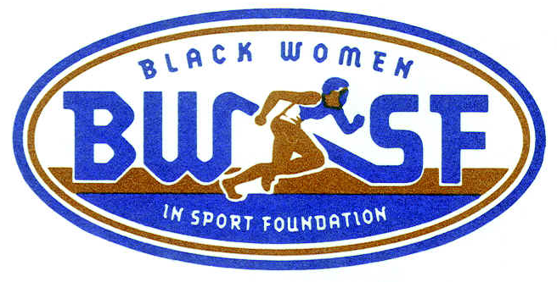

Call For Program Information
215.877.1925 ×320
Visit our website
www.blackwomeninsport.org
“Reach victory through hard work, discipline and respect for self and others”

